Sustainability,
the World Wide Wrap, and The Tree of Life
www.worldwidewrap.org/registerhere.html
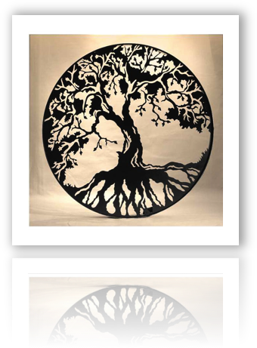

There is no doubt that the World Wide Wrap program has taken root.
Your Regional Clubs are the “roots” that sustain the FJMC World Wide Wrap program. All of our Regional Clubs are akin to the “rootlets” that bring nourishment to our program, by reaching into the earth. Now is the time to register your club.
When you register for the Wrap, you strength the tree.
Your Regions are akin to “limbs” of the tree, reaching up to the heavens. You sustain the “branches,” and their “leaves,” in the guise of Clubs and their Members.
When you register for the Wrap, we all harvest the ‘fruit’ of your labors.

