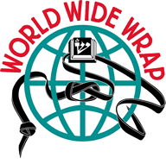

World Wide Wrap

The Ancient Prophet Hosea said:
At the Start of the Day bind yourself
to these God–Given qualities.

“Righteous,” “Law,” “Loving Kindness,” “Compassion,” “Mercy,” “Faith,” “Forever,”
and then you will have
“Knowledge Of God”

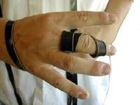

Who Doesn’t Need A Friendly Reminder?
Super Sunday (February 3, 2013)

